FIELD REPORT
Introduction
- Place: Ayara HC III
- Location: Okwerodot, Kole district
- Date of visit: 26th August 2026
1. General observations
The asset verification exercise was conducted smoothly, with no significant challenges encountered during the visit. The facility staff were cooperative and supported the team throughout the verification process.
The facility had received and retained some supporting documentation relating to the UgIFT assets. However, at the time of the visit, no official or comprehensive asset register was available for review. The verification therefore relied primarily on the available delivery note/Bill of Quantities (BoQ) as the reference document for cross-checking the assets observed at the facility.
Special note:
Asset identification and verification
Physical verification of the assets was conducted using the available delivery documentation as the main reference. While this facilitated verification of some of the items, the absence of an official asset register limited the ability to cross-reference the assets against a facility-level record.
Most of the assets observed were not engraved or marked with project-specific identification. The 04 benches were the exception, as they had identification markings (See gallery attached). The absence of project-specific identification on the other assets made it difficult to independently distinguish UgIFT-supported assets from other assets of a similar type that are present at the facility.
The delivery note/BoQ provided a useful reference for the exercise but could not fully substitute for a facility-level asset register for ongoing asset tracking and accountability.

The table below illustrates some physical status of the verified assets with photographic evidence.
Table XXX: Physical verification photos
AYARA HC III SIGN POST | 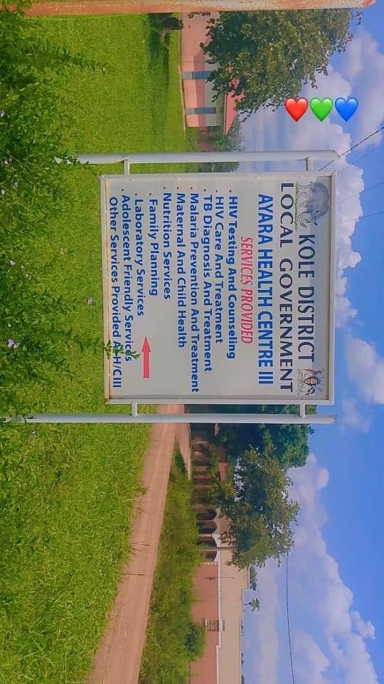
MATERNITY BLOCK (FRONT VIEW) | 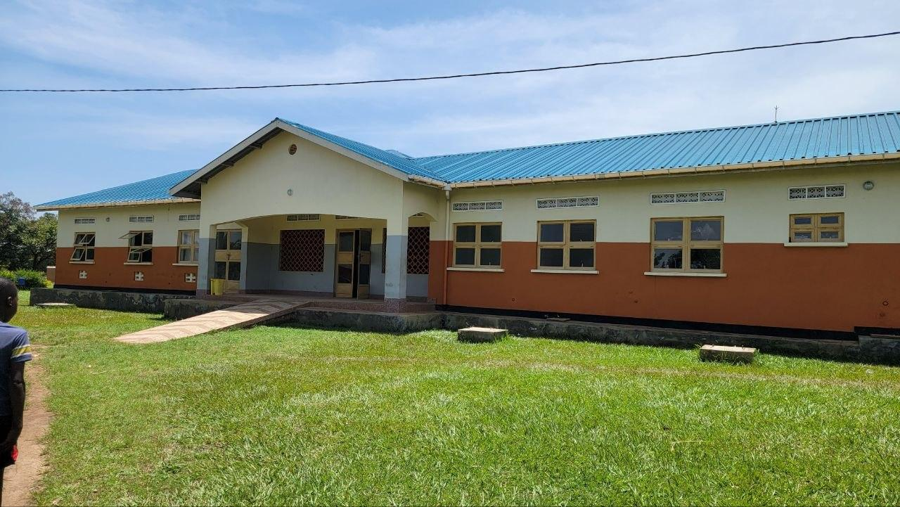
MATERNITY BLOCK (BACK VIEW WITH 3000L TANK) | 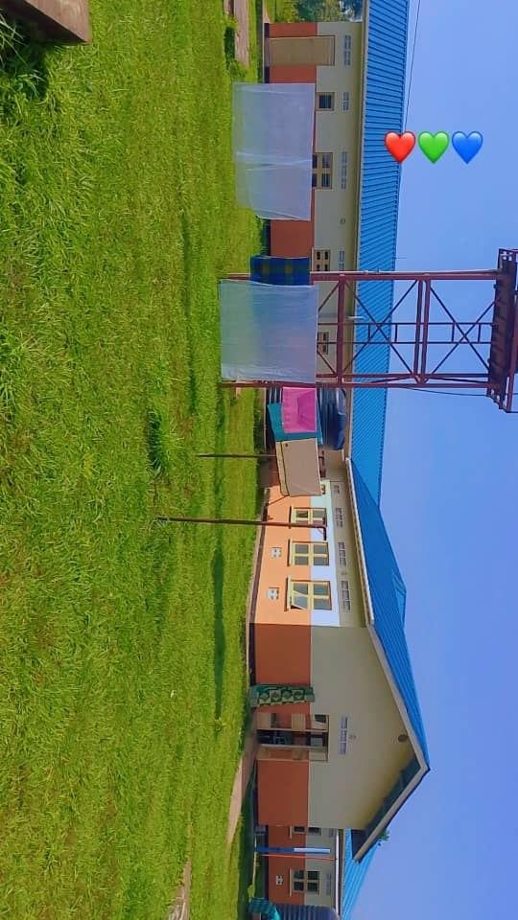
TYPICAL SET OF PATIENT’S TOILETS (FOUR STANCE TOILET BLOCK: MALE AND FEMALE) | 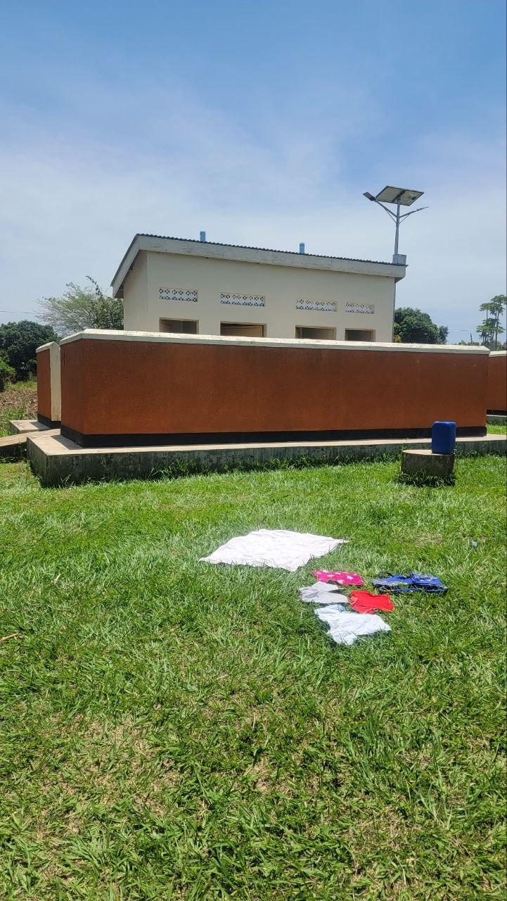
PLACENTA PIT | 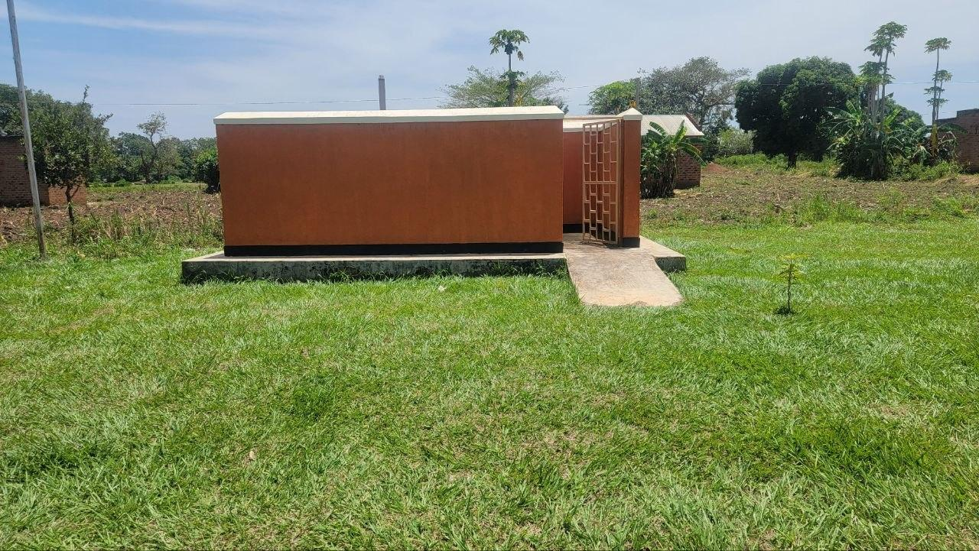
SAMPLE OF WATER TANK SERVING THE MATERNITY BLOCK | 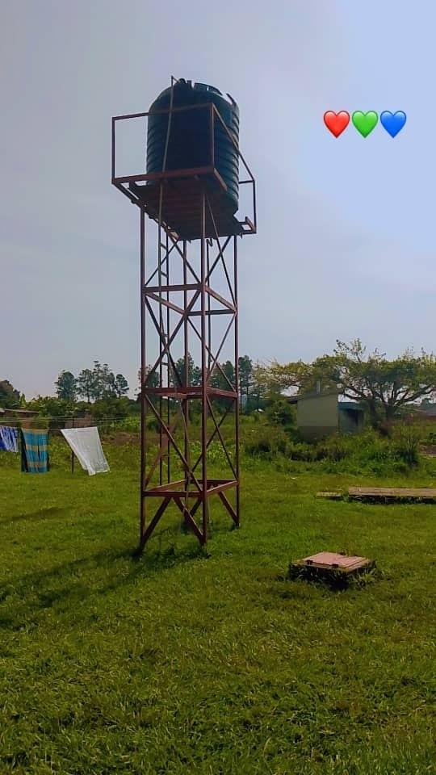
STAFF QUARTERS (TANK AND TOILETS IN THE BACKGROUND) | 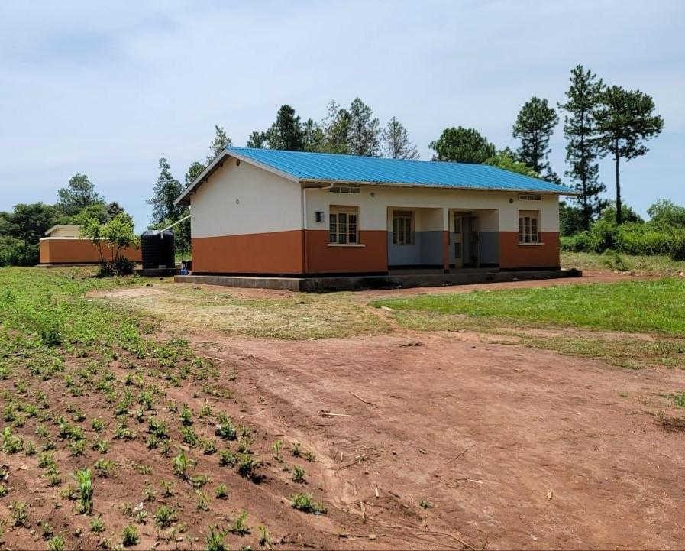
SAMPLE OF FURNTURE BENCHES (UGIFT ASSET) | 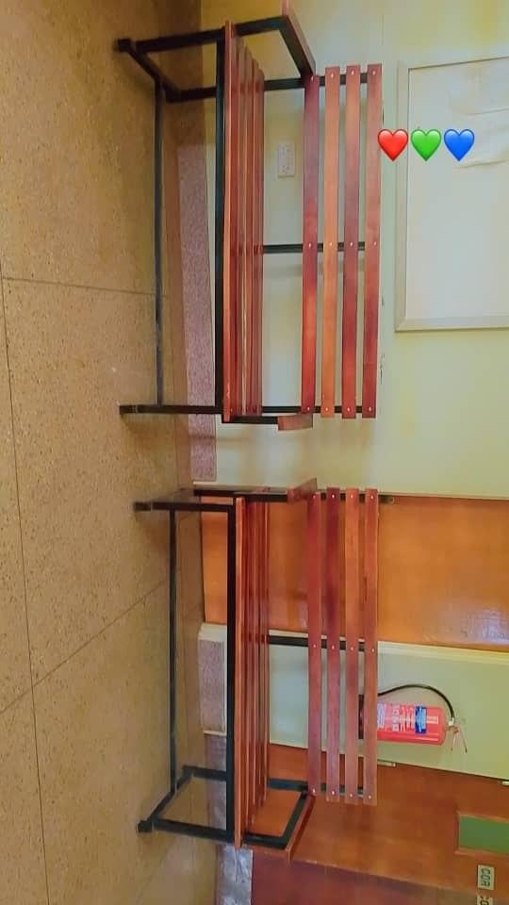
SAMPLE OF BENCH (ENGRAVEMENT MARK VISIBLE) | 